NTT Global Networks
Layer 2 NNIs

Vendor Request for Information
Rev 5.0

RFI update Date: 2 April 2020

By Backbone Team

CARRIER CONTACT INFORMATION
Company: IX Telecom Sdn Bhd | Date Completed: 7th October 2026
Company Contact: +60386868888 | Sales: Muhamad Haziq Akmal
Phone: +6019-2270445 | Product Manager:
E-mail: haziqakmal@ixtelecom.net | Reviewing Engineer:

Technical Questions:
- Design
NTT GN’s primary requirement is Point-to-Point services with Redundancy. But we would like to know what the other feasible options are.
- Do you support E-Line EPL?  (Point-to-Point) |  | 
  - Do you support E-Line EVPL?
(Point-to-MultiPoint via VLAN)
  - Do you support E-LAN EP-LAN?
(MultiPoint-to- MultiPoint)
  - Do you support E-LAN EVP-LAN?
(MultiPoint-to-MultiPoint via VLAN)
  - Do you support E-Tree?
(Point-to-MultiPoint)

  - Do you support E-Tree EVP-Tree?
(Point-to-MultiPoint via VLAN)

  - Do you support above discussed options over the same physical port?
  - Please describe layer 2 transport technologies used in your network? E.g. SDH, MPLS, Metro Ethernet etc.

  - Do you support Multicast over layer 2 services?
“If yes, is there any restriction (such as BUM limit) for multicast? Please describe.”
 | BUM Values :
  - What mechanisms do you use to forward Multicast frames? Do you handle Multicast natively or treat is as a broadcast?

  - Please describe failover or redundancy mechanism used in your backbone.

- VLAN
- Who assigns the VLAN ID’s to the customer for tagged/untagged frames?  ( NTT Global Networks prefers to assign Vlan-ids) |   
- How many VLANs per physical NNI/UNI connection?  (NTT Global Networks prefers to allocate at least 100 VLANs on NNI port.) | NNI :  UNI :
  - Is Q-in-Q supported?
    - If yes, do you pop the service tag?
    - Or do you pass the service tag?
    - Do you support multiple S-VLANs?
    - If you support multiple S-VLANs how are C-VLANs mapped to the correct S-VLAN?

    - What is the tag type you support for Inner & Outer tags? NTT Global Networks supports/requires only x8100.

- CE-VLAN ID/EVC MAP (Refer below scenario and mark the ones supported)  NTT Global Networks prefers Scenario 4. |   
Notes:

Caveats:

Port and VLAN based Scenario’s (CE-VLAN ID / EVC Map)
To clarify the technical options/set-up of Ethernet VPN service below six different scenarios to illustrate the span of the product:

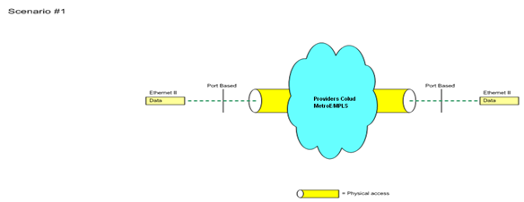
Scenario 1: Point-to Point Scenario.

Ethernet VPN in its most simple Port Based form. All traffic between the UNI’s are transported un-tagged in one VLAN. In Scenario 1 only one EVC can exist with one psychical LAN port. Provider assigns a VLAN ID to identify the logical path through Provider's Network. Any tags if assigned by provider should be stripped on/off at the Providers edge.

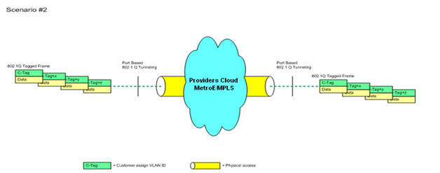

Scenario 2: Port based with 802.1Q Tunneling*
Port based Point-to-Point Scenario. Equal to Scenario #1 but configured with 802.1Q Tunneling. The customer assigns the data frame with his own VLAN ID (C-tag). This scenario gives the customer the possibility to separate his traffic in 2-4092 inner VLANs. Provider assigns a VLAN ID (S-tag) to identify the logical path through Provider's Network. The S-tag is stripped on/off at the UNI’s. If the customer does not add any C-tag to the data frame, Provider will transport the data frame unaffected from A to B or vice versa – like in scenario 1.

A Provider Ethernet VPN solution can be VLAN based in one end and Port-based in the other as illustrated in this Hub & Spoke Scenario 3

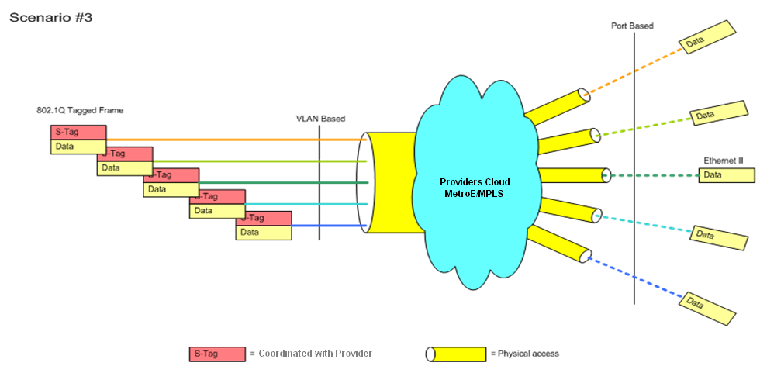
Scenario 3: Multiple Point-to Point Scenario. In this example NTT Global Networks has one trunk access to Provider and multiple Ethernet VLANs at the HUB end and access lines in the Spoke end each with one corresponding VLAN. Before a data frame is send from the LCC/HUB, NTT Global Networks must assign the VLAN ID from coordinated VLAN range with Vendor. The assigned VLAN ID is stripped on/off at the UNI. Data send from a Spoke to the RPC/HUB will be assigned with a corresponding tag by provider edge to CPE link.

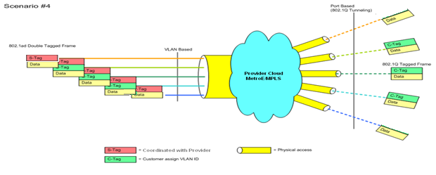

Scenario 4: Multiple Point-to-Point Scenario. Equal to Scenario #3 but the Spokes are Port Based configured with 802.1Q Tunneling.
By adding an inner VLAN (C-tag) the customer can divide each Ethernet VPN into 2- 4094 VLANs.

Before a data frame is send from the HUB, NTT Global Networks may assign both the VLAN ID, S-tag is from the coordinated VLAN range and the inner C-Tag are any VLAN rage to be provided to CPE. S-tag assigned at RPC/HUB is stripped on/off at the UNI.
Before a data frame is send from the SPOKE to the HUB the CPE must assign the inner VLAN (C-tag).
Provider to assign the S-tag on Providers edge to CPE link.
# Please note, some customers can use C-tag, and other customers in the same trunk do not.

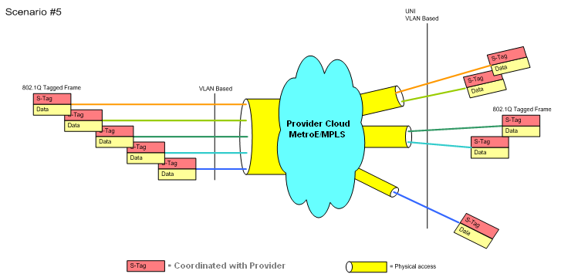

Scenario 5: Multiple Point-to Point Scenario. VLAN Based. As shown VLAN Based UNIs gives the possibility of several Ethernet VPNs at the same physical access. Before a data frame is send between from Hub/LCC to Spoke and vice versa, the NTT Global Networks must attach the outer VLAN ID’s coordinated with Provider.

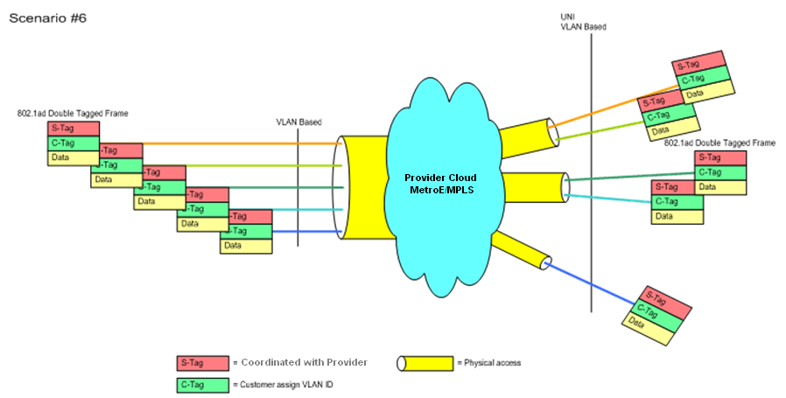
Scenario 6: Multiple Point-to Point Scenario. Equal to Scenario #5 - but by adding an inner VLAN (C-tag) the NTT Global Networks can divide each Ethernet VPN into 2- 4094 VLANs. Before a data frame is send between from Hub to Spoke and vice versa, the NTT Global Networks must attach the outer VLAN ID’s coordinated with provider.

- Bandwidth
- What port speeds do you support for NNI port? |       
  - What port speeds do you support for Customer port /UNI port?

- Do you support sub rate access speeds? | 
    - If yes, please list:
  - Bandwidth management on sub rate services:
    - Traffic policed
    - Shaped
    - In which way do you police or shape customer traffic, L1 or L2?
(1) L1 Frame (This includes IFG,PA and SOF)
(2) L2 Frame (From DA to FCS)
Notes:

- QOS/COS
  - Please define how you handle egress traffic classification for directing traffic to the relevant class for scheduling of traffic egress from the PE for traffic destined to the CE.
Please define if you can handle different classification policies for each customer, or customer connection.
  - Are your lower classes of service allowed to utilize unused (idle) bandwidth of upper classes of service?
  - How do you enforce the CIR for the different classes of service?
  - NTT Global Networks requires full inbound and outbound traffic statistics on a per queue basis, including egress queuing information related to queue drops.
Can you support the above?
Inbound Traffic Classification
- Can you classify on the following? |         
  - Are customers’ 802.1p bits unmodified?
  - Does incoming classification need to match your values or can you translate?
  - Can you police traffic classes to specified rates?
  - Is the TOS byte in the customer IP packet ever over-written?
Traffic Classes and Per Hop Behaviour
  - Cover queue assignment for each class and where normal internet traffic is assigned.
  - Cover relative queue service factor amongst the utilized queues. Strict Priority Queuing?
  - Queue allocation and service rate?
  - Describe use of (W) RED, if applicable.
Notes:

Caveats:

- MAC
- Do you have MAC limits/filters? | 
    - If yes, are limits per NNI/UNI physical port basis?
      - If yes, how many?

    - If yes, are limits per customer port basis?
    - If yes, are limits per VLAN?
    - If yes, are limits per cloud basis?
    - If yes, please specify how this is enforced. If limit is exceeded or the MAC address changes, what are the effects?
NTT Global Networks would like Provider to “Flood as unknown unicast” in this situation.

Notes:

- Product Questions:
  - Do you offer Jumbo Frames (MTUs > 1500 bytes e.g. 9000 bytes)?
    - What is the Maximum? NTT Global Networks prefers 9000 MTU.
    - If “Other”, please explain:
    - Is there any restriction on minimum frame size? How does your network treat 64 byte frame including vlan-tag?
  - Do you offer multiple COS at Layer 2?
    - If so, how many?

  - Do you have a maximum bandwidth subscription rate for the highest grade CoS (e.g. real time for highest grade)?
    - If yes, what is the rate :
UNI : On a 10M port?
On a 100M port?
On a 1000M port?
(Example: 50 Mbps of "REAL TIME COS" on 100Mbps port)

NNI/UNI
On a 100M port?
On a 1000M port?
(Example: 50 Mbps of "REAL TIME COS" on 100Mbps port)
  - Do you have a maximum bandwidth subscription rate for the medium grade CoS (Enhanced Data or medium grade)?
    - If yes, what is the rate:
UNI On a 10M port?
On a 100M port?
On a 1000M port?
(Example: 50 Mbps of "REAL TIME COS" on 100Mbps port)

NNI/UNI
On a 100M port?
On a 1000M port?
(Example: 50 Mbps of "REAL TIME COS" on 100Mbps port)
  - Do you have a maximum bandwidth subscription rate for the lowest grade CoS (Best Effort or low grade)?
    - If yes, what is the rate:
UNI On a 10M port?
On a 100M port?
On a 1000M port?
(Example: 50 Mbps of "REAL TIME COS" on 100Mbps port)

NNI/UNI
On a 100M port?
On a 1000M port?
(Example: 50 Mbps of "REAL TIME COS" on 100Mbps port)
  - In which way do you define subscribed bandwidth, L1 or L2?
    - L1 Frame (This includes IFG,PA and SOF)
    - L2 Frame (From DA to FCS)

  - To describe how your service sets <CIR, CBS, EIR, EBS, CM, CF> for ordered OVC speed.
  - What is your One-way Frame Loss Ratio? :
SHOULD be under 0.1%
  - Do you require the end-user customer to set the .1p bits?
  - Do you re-write the end-user customer’s .1p bits prior to sending the frame to NTT Global Networks over the NNI/UNI?
    - What are the .1p markings associated with the CoS/Level of Service offerings?
  - Is MAC in MAC (802.1ah) supported?
    - If yes to above, are there any limits applied to the customer port? Please explain.
  - Are you able to remotely loop a device at the customer premises 24/7?
    - If not when is this feature expected?
  - Will NTT Global Networks be able to remotely loop said device at the customer premises 24/7?
    - If not when is this feature expected?
  - Does this looping mechanism provide the appropriate rewriting of source and destination MACs to allow Layer 2 testing?
  - Do you support burstable Layer 2 Circuits?
  - Do you have any measures to mitigate & contain the potential broadcast storm in your network?
Please describe below.
(E.g. What switch features do you use?)

  - Do you require to install any device like NTU/NID to terminate link at CPE side in Customer location or at NNI side in NTT Global Networks premise?
Please provide datasheets/URLs for these devices, if reply is “YES”

Notes:

Caveats:

- Reporting
  - Do you provide Performance reporting including Frames sent & received by VLAN, Frame Delivery %, SLA reporting including MTTR, Availability % etc.

If so, please provide samples.
Notes:

Caveats:

- SLA
- What is your minimum Availability SLA? |     
    - If ‘Other”, please explain:

  - What is your minimum Latency SLA?

  - What is your minimum Jitter SLA?

  - What is your minimum Frame Delivery SLA?
  - What is your quote validity time period?

  - Please provide an SLA matrix along with credits offered by COS offered.
  - Please provide your MTTR SLA
Notes:

Caveats:

- Monitoring
- Do you support Ethernet OAM as identified in 802.1ag, & Y.1731 or 802.1ah | 
  - If you cannot support full 802.1ag, 802.1ah & Y.1731 with Ethernet OAM, will you at a minimum support, unencumbered / not rate-limited ICMP Echo-responses to our Echo-requests for testing?
  - Do you end to end circuit monitoring? If so, please describe in detail.
Notes:

Caveats:

- Backup NNI
  - Do you support Node level redundancy?
Node Redundancy: (Option A in below diagram)
At the NNI end - > Two separate NNI trunks from providers two PEs/Devices in the same PoP.
At the CPE end - > We require 2 vlans at CPE end. Provider will broadcast first vlan on primary NNI & 2nd vlan on secondary NNI.
Both the NNIs in Active-Active mode.
Failover by NTT Global Networks using layer 3 routing.
  - Do you support PoP Level redundancy?
( Option B in below diagram)
At the NNI end - > Two separate NNI trunks from providers two PoPs to NTT Global Network’s two PoPs.
At the CPE end - > We require 2 vlans at CPE end. Provider will broadcast first vlan on primary NNI & 2nd vlan on secondary NNI.
Both the NNIs in Active-Active mode.
Failover by NTT Global Networks using layer 3 routing.
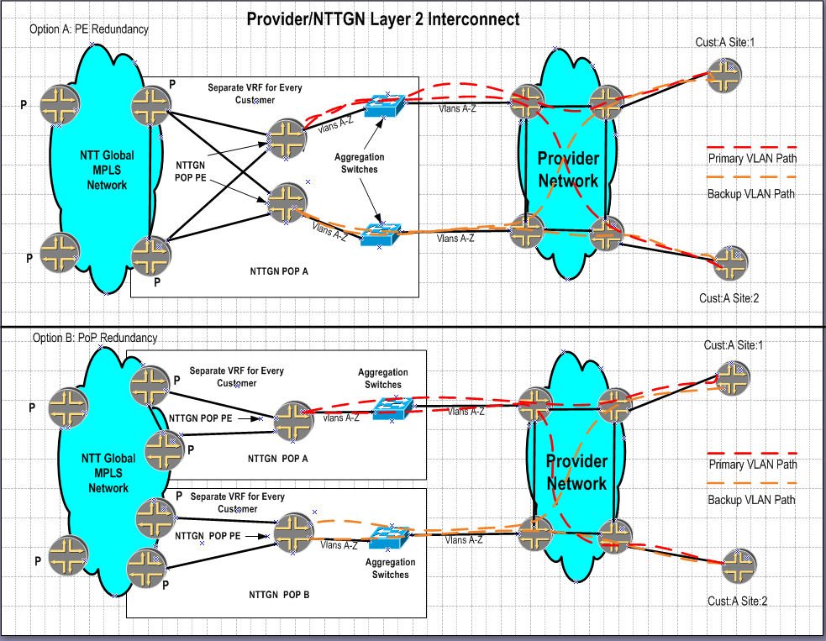

Notes:

Caveats:

